SEC Form 3
FORM 3 | UNITED STATES SECURITIES AND EXCHANGE COMMISSION
 | Washington, D.C. 20549
 | Washington, D.C. 20549 |  | OMB APPROVAL
 | INITIAL STATEMENT OF BENEFICIAL OWNERSHIP OF SECURITIES
 | INITIAL STATEMENT OF BENEFICIAL OWNERSHIP OF SECURITIES |  | OMB Number: | 3235-0104
 |  |  | Estimated average burden
 | Filed pursuant to Section 16(a) of the Securities Exchange Act of 1934 |  | hours per response: | 0.5
or Section 30(h) of the Investment Company Act of 1940
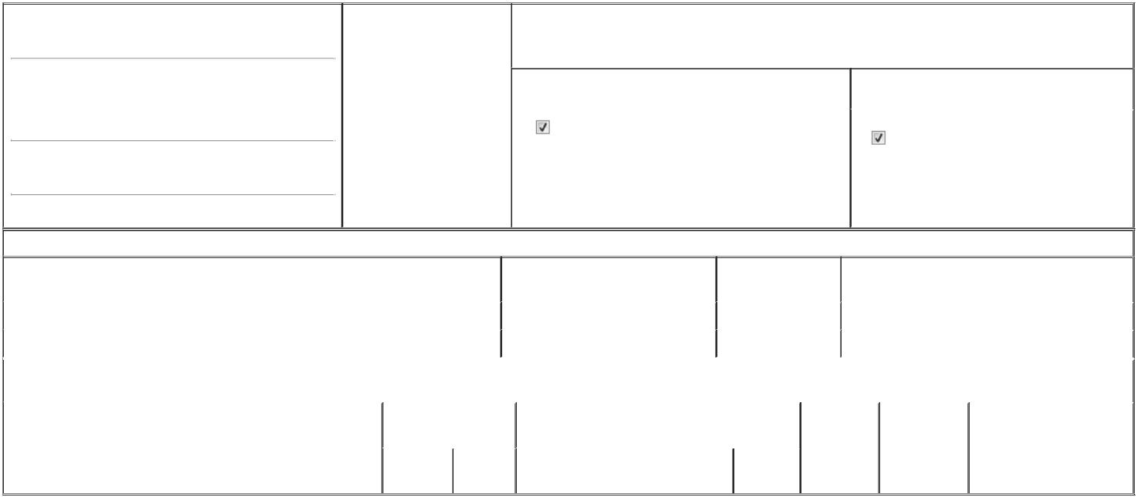

1. Name and Address of Reporting Person*
Daniel Willis Johnathan

(Last) (First) (Middle)

C/O THE BALDWIN INSURANCE GROUP, INC. 4211 W. BOY SCOUT BLVD., SUITE 800

(Street)

TAMPA FL 33607

- Date of Event Requiring Statement (Month/Day/Year)
06/11/2026

3. Issuer Name and Ticker or Trading Symbol

Baldwin Insurance Group, Inc. [ BWIN ]

4. Relationship of Reporting Person(s) to Issuer |  | 5. | If Amendment, Date of Original Filed (Month/Day/Year)
(Check all applicable)
Director | 10% Owner
Officer (give title | Other (specify below) | 6. | Individual or Joint/Group Filing (Check Applicable Line)
below) | Other (specify below) |  | Form filed by One Reporting Person
Interim CAO |  |  | Form filed by One Reporting Person
Interim CAO |  |  | Form filed by More than One Reporting Person

(City) (State) (Zip)

Table I - Non-Derivative Securities Beneficially Owned

1. Title of Security (Instr. 4) | 2. Amount of Securities Beneficially | 3. Ownership Form: | 4. Nature of Indirect Beneficial Ownership (Instr. 5)
 | Owned (Instr. 4) | Direct (D) or Indirect
 |  | (I) (Instr. 5)

 | Class A Common Stock |  |  |  | 35,406⁽¹⁾ | D
 | Class A Common Stock |  |  |  | 3,147⁽²⁾ | I | By IRA⁽³⁾
 |  |  | Table II - Derivative Securities Beneficially Owned
 |  | (e.g., puts, calls, warrants, options, convertible securities)
 | 1. Title of Derivative Security (Instr. 4) |  | 2. Date Exercisable and |  | 3. Title and Amount of Securities Underlying |  | 4. | 5. Ownership | 6. Nature of Indirect Beneficial
 |  |  | Expiration Date |  | Derivative Security (Instr. 4) |  | Conversion | Form: Direct | Ownership (Instr. 5)
 |  |  | (Month/Day/Year) |  |  |  | or Exercise | (D) or Indirect
 |  |  |  |  |  |  | Price of | (I) (Instr. 5)
 |  |  |  |  |  | Amount or | Price of | (I) (Instr. 5)
 |  |  |  |  |  | Amount or | Derivative
 |  |  | Date | Expiration | Title | Number of | Security
 |  |  | Exercisable | Date | Title | Shares

Explanation of Responses:

- Includes (i) 25,406 shares of Class A Common Stock that such Reporting Person was entitled to receive as a former member of Cobbs Allen Capital Holdings, LLC ("CAC") pursuant to the terms of that certain Transaction Agreement, dated December 2, 2025 by and among The Baldwin Insurance Group, Inc. (the "Company"), CAC and the other parties named therein, the issuance of which was approved by the Board of Directors of the Company pursuant to Rule 16b-3(d)(1) and (ii) 10,000 restricted shares of Class A Common Stock that vest in four equal installments on each of April 1, 2027, April 1, 2028, April 1, 2029, and April 1, 2030, in each case, subject to such Reporting Person's continued employment through each vesting date.

- These shares of Class A Common Stock represent shares such Reporting Person was entitled to receive as a former member of CAC pursuant to the terms of that certain Transaction Agreement, dated December 2, 2025 by and among the Company, CAC and the other parties named therein, the issuance of which was approved by the Board of Directors of the Company pursuant to Rule 16b-3(d)(1).

3. These shares of Class A Common Stock are held by such Reporting Person's individual retirement account, for which the Reporting Person remains the beneficial owner.

Remarks:

/s/ Seth Cohen, as Attorney-in-Fact, for

Willis Johnathan Daniel

** Signature of Reporting Person

06/16/2026

Date

Reminder: Report on a separate line for each class of securities beneficially owned directly or indirectly.

* If the form is filed by more than one reporting person, see Instruction 5 (b)(v).

- Intentional misstatements or omissions of facts constitute Federal Criminal Violations See 18 U.S.C. 1001 and 15 U.S.C. 78ff(a). Note: File three copies of this Form, one of which must be manually signed. If space is insufficient, see Instruction 6 for procedure.
Persons who respond to the collection of information contained in this form are not required to respond unless the form displays a currently valid OMB Number.



